|  |  |  |
| --- | --- | --- |
|  | **BOSTON**  **UNIVERSITY** | **METROPOLITAN COLLEGE**  **DEPARTMENT OF ADMINISTRATIVE SCIENCES** |

**AD 616: Enterprise Risk Analytics**

**Assignment 1**

**Aravind Hanumantha Rao**

**What to submit?**

Please submit (i) a word file explaining in detail your answers to each question (you can use screenshots of the R to explain your answers) AND (ii) an R file with a separation for each question. For each question, make sure you develop the model and present the simulation results – the R file should be self-explanatory. **The assessment of your work will include both the accuracy and the clarity of your word file and the R Code.**

1. Consider a call center that receives its demand over a set of different travel websites. The weekly demand for each website is normally distributed with a mean and standard deviation given in Table 1. Develop a R script that creates a simulation with 100,000 trials to determine total call center demand.

Table 1: Weekly demand of travel sites (in hours)

|  |  |  |
| --- | --- | --- |
| Travel Site | Mean | Standard Deviation |
| A | 200 | 20 |
| B | 50 | 10 |
| C | 100 | 15 |
| D | 150 | 30 |
| E | 100 | 30 |
| F | 100 | 10 |

1. What are the mean and standard deviation of total call center demand according to your simulation?

Mean and standard deviation is determined from the total call center from all the random normal variables. total call center is calculated after normally distributing all the variables and adding up all the travel sites.

1. Develop a histogram that models the risk profile for total call center demand.

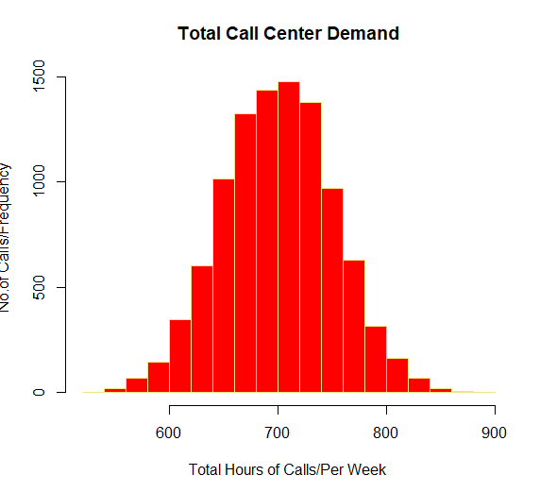

1. A cell phone manufacturer is considering to offer a refund to its customers whose battery fails before 5 years. The refunds start at $10, and increase by $1.50 for every month the battery falls short of 5 years. For example, a customer whose battery fails after 4 years and 6 months would receive a refund of $19. A customer whose battery fails after 5 years would receive no refund. Previous studies show that a battery’s life is normally distributed with a mean of 7 years and standard deviation of 2 years. Develop a simulation with 100,000 trials for the amount of a refund.
2. According to your simulation, what is the expected cost per cell phone to the manufacturer of this offer?

Replacement is 45.46 . To derive to this calculation , we had to calculate the replacement cost . includes the refund for the phones less than 5 years and the total battery life that falls short of 5 years and divide it by the total trials.(100000)

1. According to your simulation, what is the probability a refund will be paid?

15.84 .phones less than 5 years divided by total trials (100000) *100 , gives the probability

1. According to your simulation, what is the average cost per refund?

To calculate the average cost per fund , we need to know the replacement cost and phones less than 5 years.

1. A coffee cart opens at 7:00 am, and they generally try to prepare a batch large enough to accommodate their customers until 10:00 am, when the cart closes. The operator only sells 16 oz. servings, and each serving costs $0.50 to prepare, which includes all costs of production and any dairy/sweetener customers may add. Any coffee that isn’t sold before 10:00 am is considered stale and disposed of for no monetary gain. When purchased, the coffee is poured into a ripple cup, which costs an additional $0.15 per cup. Demand over this period is normally distributed with a mean of 125 and a standard deviation of 35. Each cup retails for $2.75. The operator of the cart must also purchase a municipal license, which costs a flat $100 for the three hours. Assume there are no other costs associated with the cart. Develop a R model with 100,000 trials that simulates the daily profit resulting from the preparation of 75, 100, 120, 140, 160, and 180 servings of coffee a day (run them one at a time).
2. For each option, what is the expected profit, and which option results in the highest expected profit?

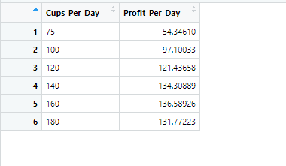

To derive to the expected profit the following measures had to be taken place to get the values.

1. Cost of the cup is 0.15 +0.5 and the profit of the cup or margin is 2.75-0.65
2. Rent is 100
3. Now for each serving of coffee we need to calculate whether they make a profit or not.
4. Pmin because the minimum they can sell in that day depends upon the servings of the coffee run on the day.

The conditions that had to be taken place is whether the customers were served with the ripple cup or served without it . the 2 conditions that I have kept is the total money they make from minusing the cost of cup and servings with the rent. The other one is without the cup and therefore only the cost of production is taken into consideration. This would give the expected profits for all the coffee servings and help in identifying the profit_per_day

1. Create a histogram that displays the risk profile of profit for the number of servings with the highest expected profit.

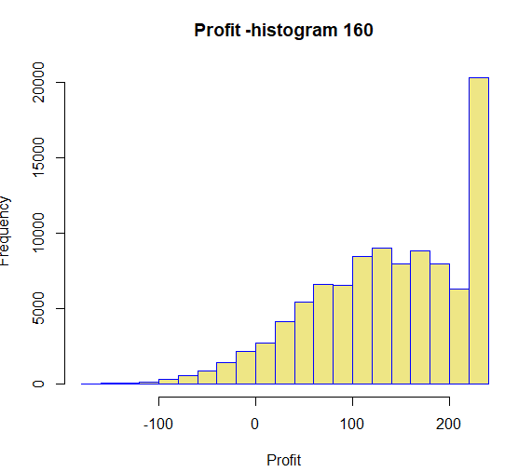

As seen from the table , the highest profit was from 160 servings per day.